DELIVERY NOTE 送货单 SE9405/SALLY

 | SHIPPER: | ABC INTERNATIONA TRADING
 | DELIVERY LOCATION  发货地址: | COSL MIDDLE EAST FZE(IRAQ BRANCH)  Fauqi Camp Burzugan Terminal in Missan Oil Field, Missan Province, Iraq.  Tel: +964XXXXXXX  Mr. ZHANG
DESCRIPTION OF GOODS货品描述:

 | SL. NO. | ITEM/S 货物 / QTY  数量 | SHIPPING MARKS  货运标识
 | 1 | SPARE PARTS  8 PAPER BOX  3 PALLET | 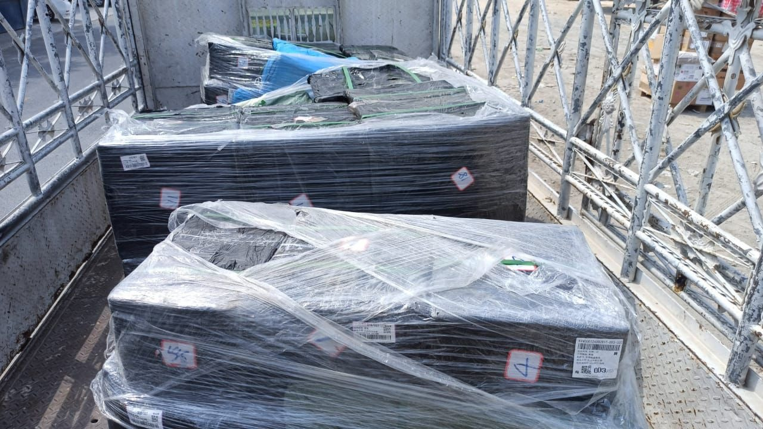  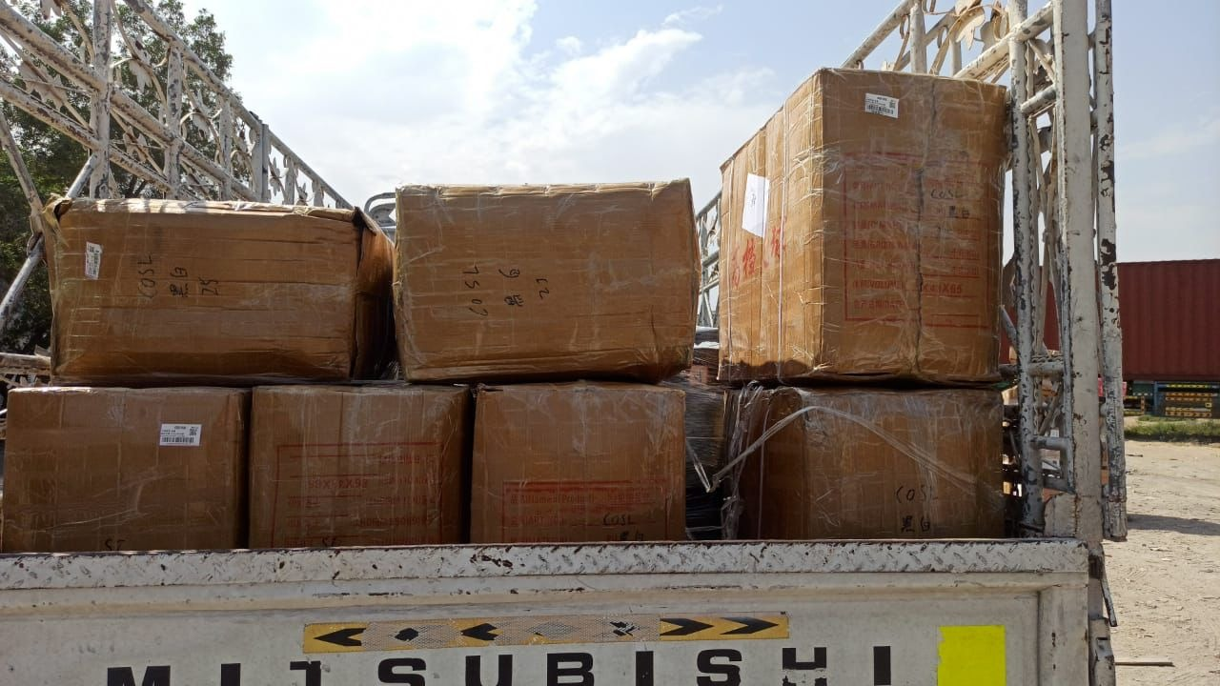

DELIVERED BY送货人:
 | Date  日期: | Truck Plate No.  卡车牌号: | Driver Name  姓名: | Mobile No.  联系电话:
I hereby confirm that the goods are complete and in good condition.我在此确认货物完好无损。
RECEIVED BY签收人:
 | Date  日期: | Name of Receiver  签收人: | Signature  签字: | Mobile Number  手机号:

