For PROJECT :HONG HUA AD DRILLING RIG PROJECT
Cargo description: 750HP POWER DRILLING RIG 6300CBM 134 PACKAGES
DELIVERY: HABSHAN BAB OIL FILED
Loading Frequency: daily on rotation basis, SUNDAY no loading. Offloading: Next day. Estimated 70 trips, 5 days, Delivery : FEB-15-20.

Introduction

Route : Khalifa Port to Habshan Rig AD 234.

The purpose of this Route Survey is to investigate all the possibilities for loading the pipes from Khalifa Port to HONG HUA AD 234 RIG site. The survey describes the required adjustments necessary to get free access from loading area to the offloading site for the truck - trailers.

For the results the following have been taken into consideration:

- The most cost-effective results.

- The civil infrastructure.

- The environmental effects.

- Route avoiding overhead and over width obstructions, e.g. bridges, gantries, power lines and sign poles.

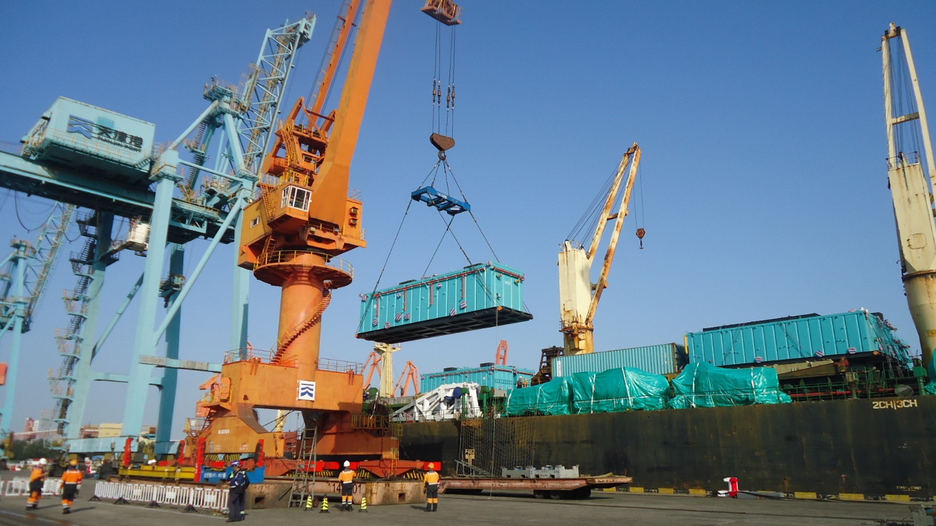

 |  |  | RIG 234 | TOTAL  Trips | Daily Pcs
 | 15-Feb | Day1 | DIRECTLY DISCHARGE | 10 | 10
 | 8-Aug | Day2 | Mix Loading | 15 | 20
 | 9-Aug | Day3 | Mix Loading | 20 | 40
 | 10-Aug | Day4 | Mix Loading | 20 | 40
 | 11-Aug | Day5 | Mix Loading | 5 | 24
 |  | TOTAL ESTIMATED TRIP |  | 70 | 134 PKG

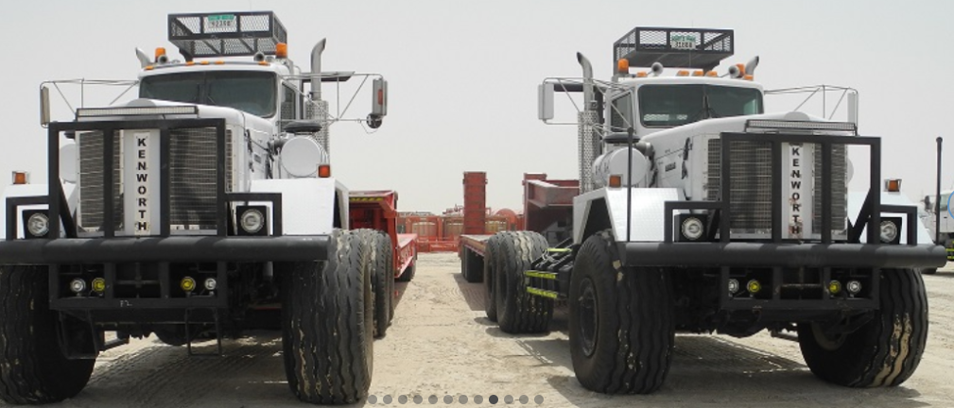

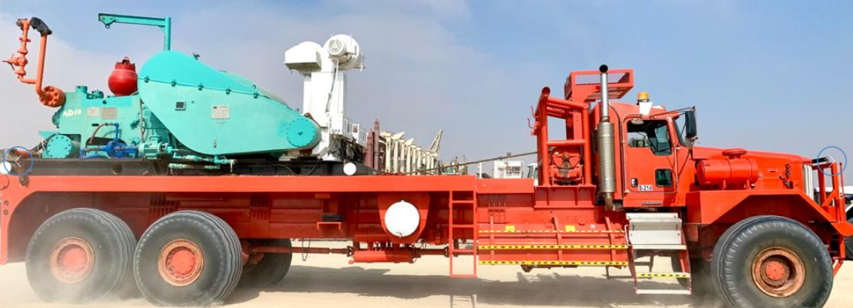

Route Map Khalifa Port to HABSHAN BAB AD RIG 234, Non CNIA

LOCATION LINK：https://maps.app.goo.gl/FkZQ1oDRK7obqS5x5

FROM KHALIFA PORT TO SITE TOTAL DISTANCE 253 KM

BLACK TOP ROAD TO GRAVEL ROAD-------12KM
GRAVAL ROAD TO SANDS ROAD-------------12 KM
SANDS ROAD IS VERY LOOSE AND MUST NEED SANDS TYRE TRUCK FOR DELIVERY AND PRE-PAVE ROAD BY DOZER 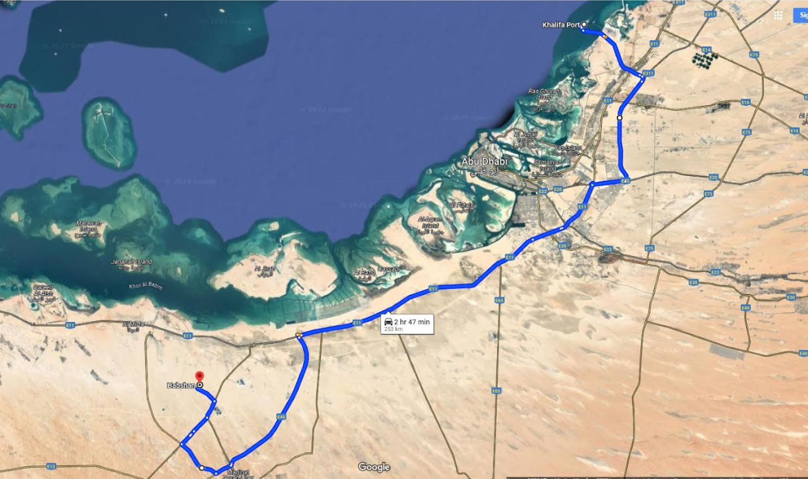

- Route Photos from Khalifa Port to AD 234 HABSHAN BAB, Non CNIA,

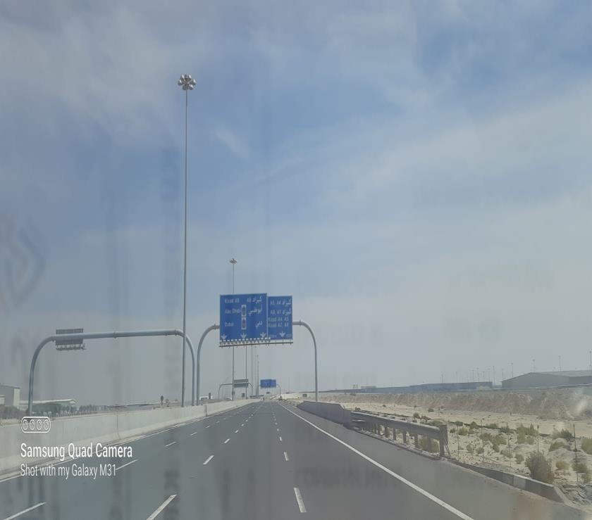
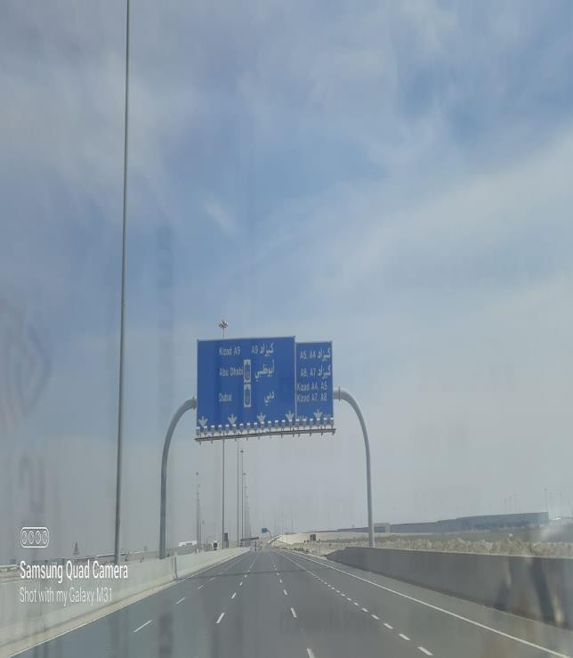
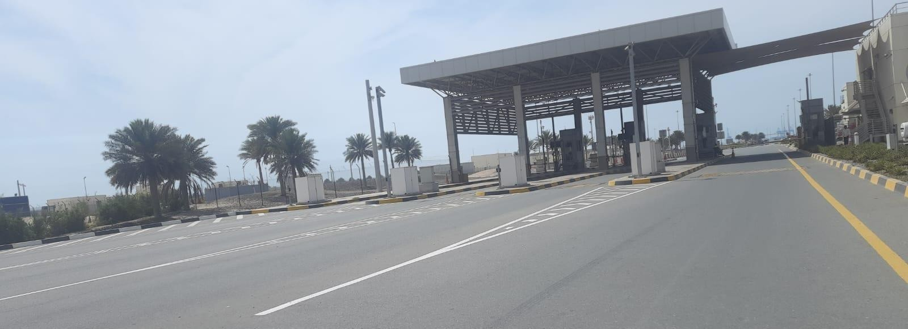
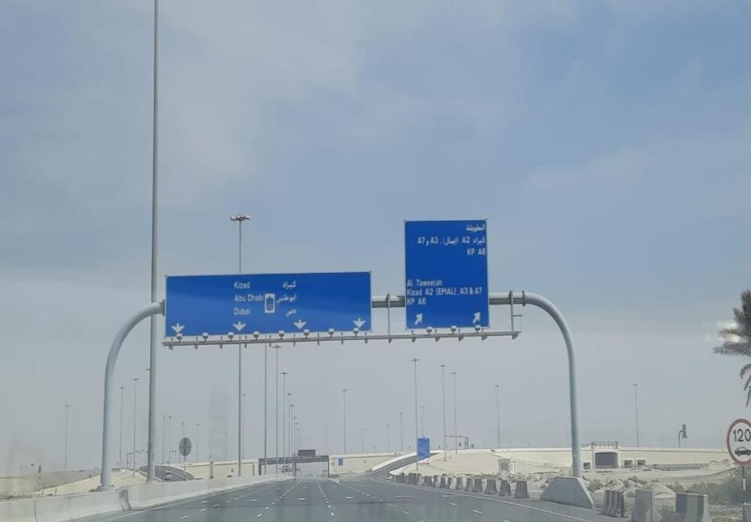
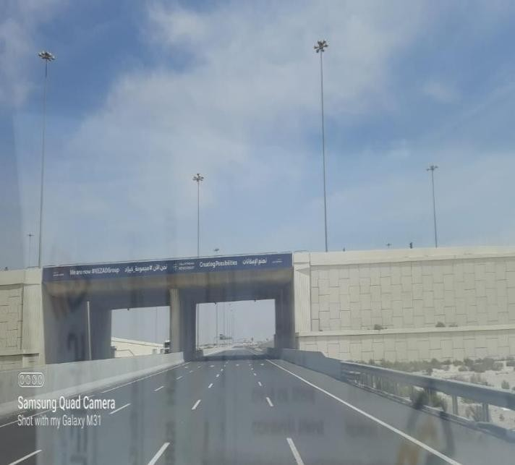
Khalifa Port Exit Gate.

Sign Gantry Height 6.00m. Bridge Height 6.00m.

Sign Gantry Height 6.10m. Sign Gantry Height 6.10m
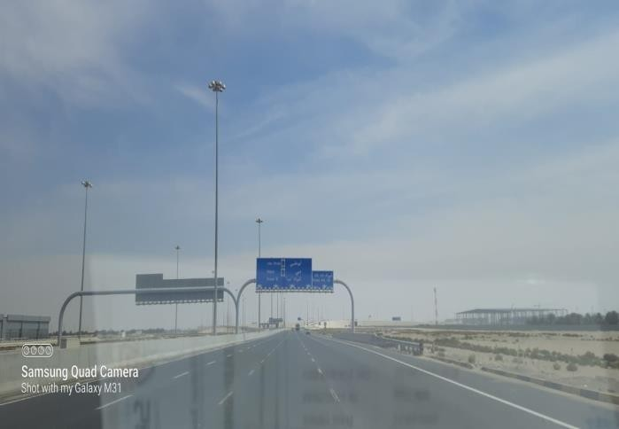
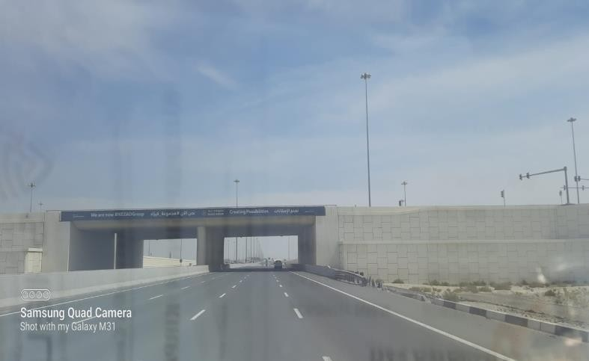

Bridge Height 6.00m. Sign Gantry Height 6.10m.
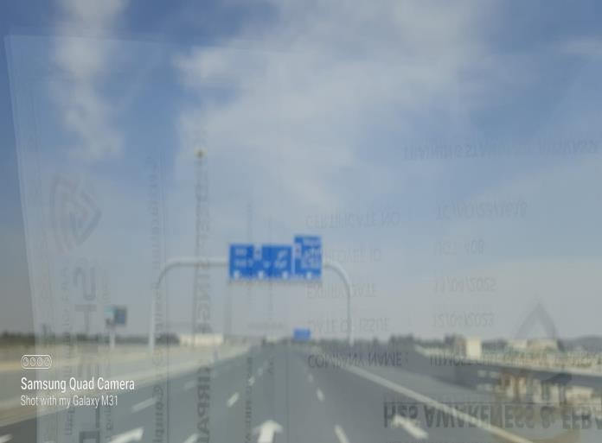
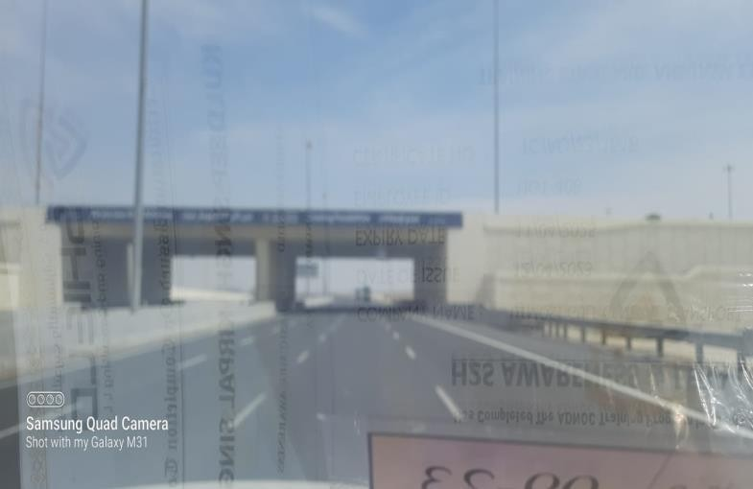

Bridge Height 6.10m. Sign Gantry Height 6.10m.
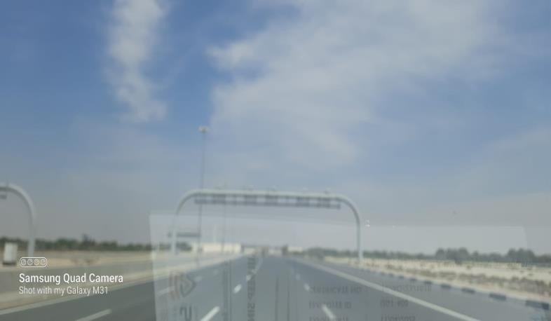
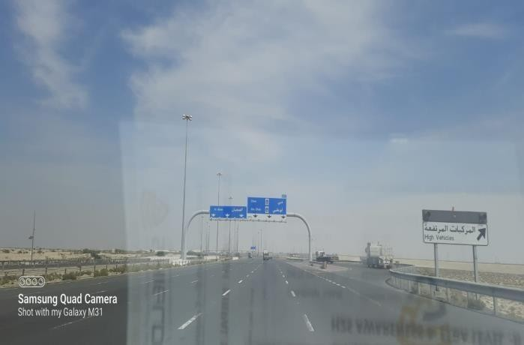

Sign Gantry Height 6.15m. Sign Gantry Height 6.15m.
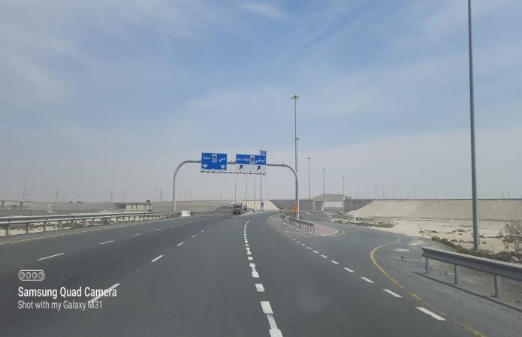
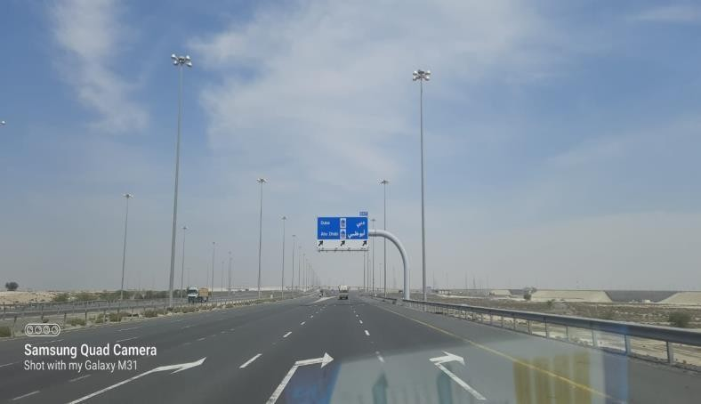

Sign Gantry Bypass Available.
Take Exit to Abu Dhabi.
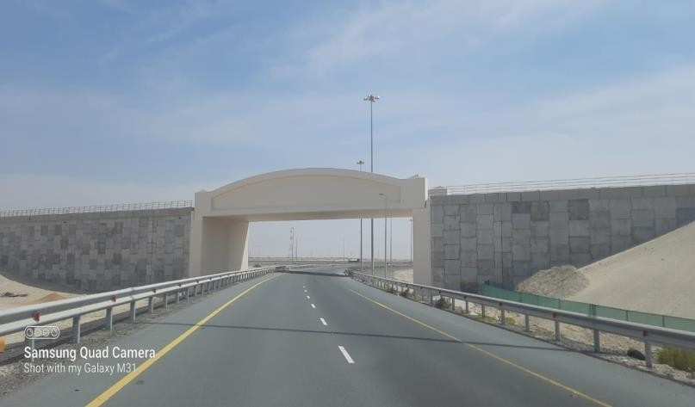
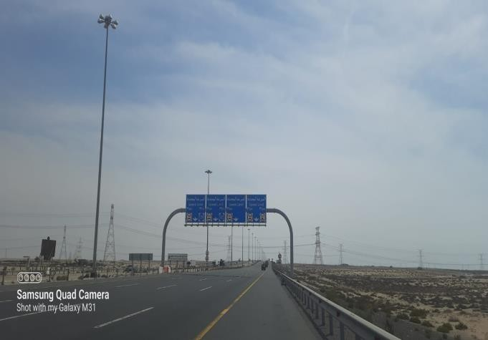

.

Sign Gantry Height 6.00m.
Bridge Height 6.05m

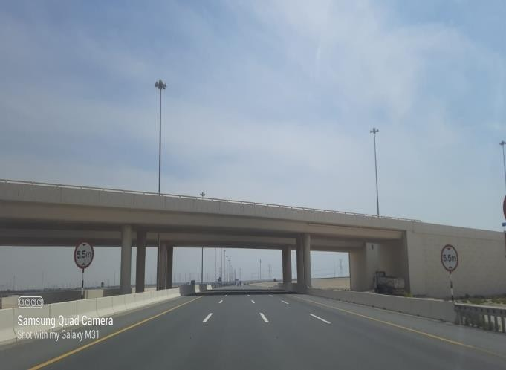
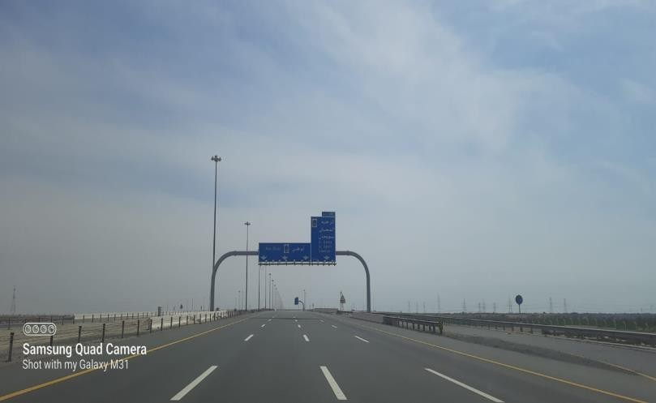

.

Bridge Height 6.00m.
Sign Gantry Height 6.00m.

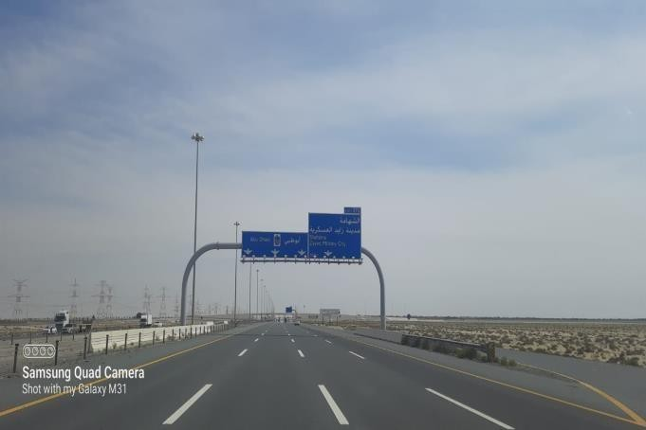
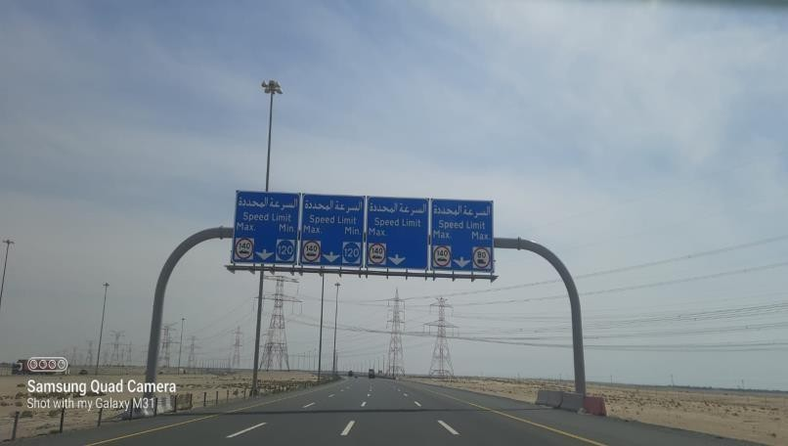

Sign Gantry Height 6.00m. Sign Gantry Height 6.00m.
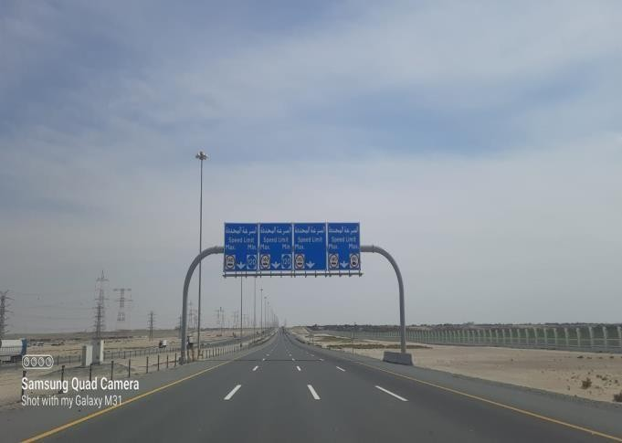
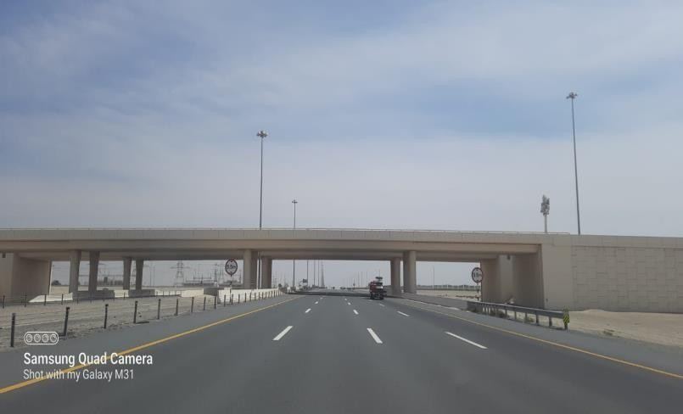

Sign Gantry Height 6.00m.

Bridge Height 6.05m.

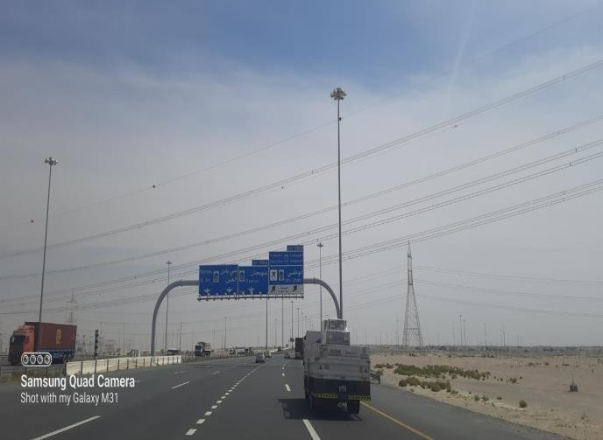
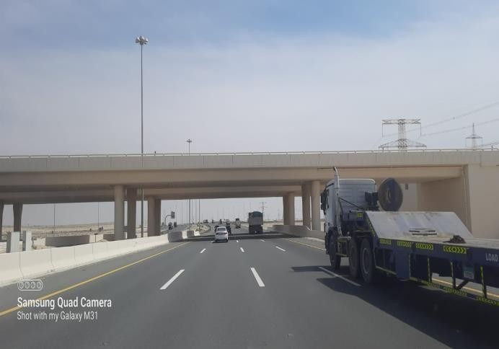
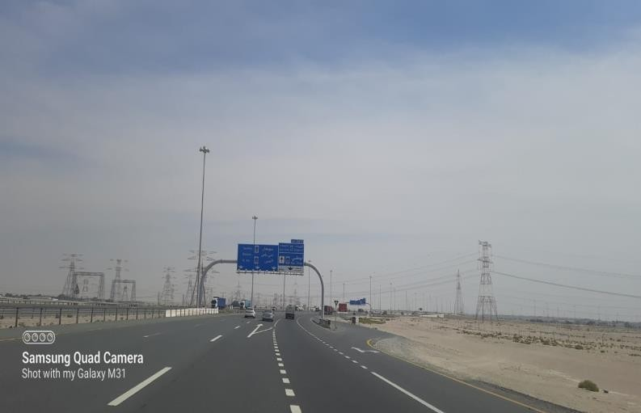
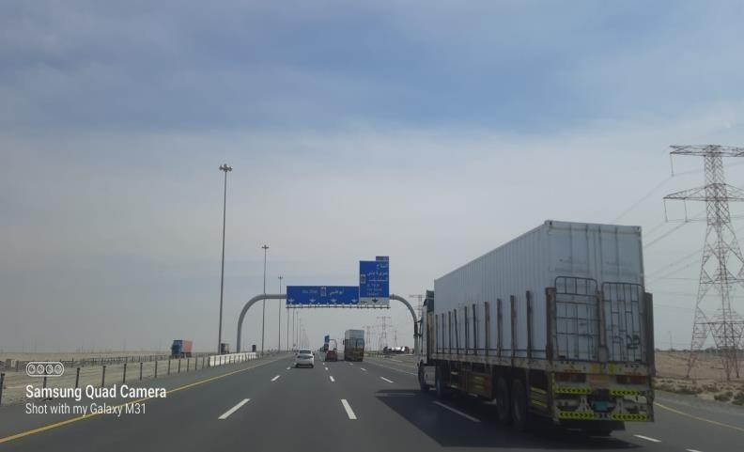

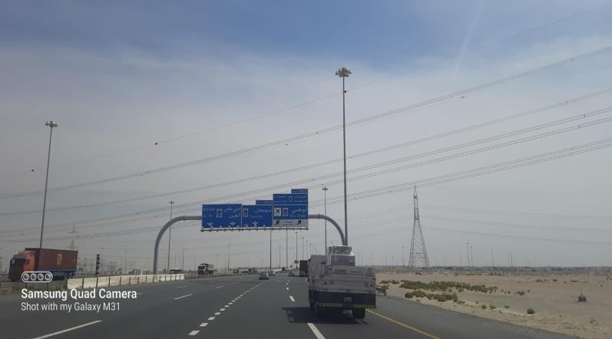
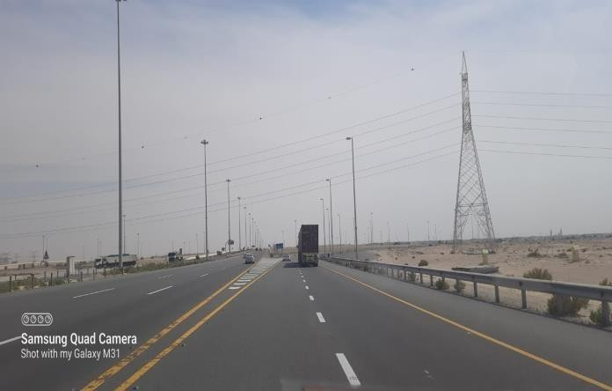
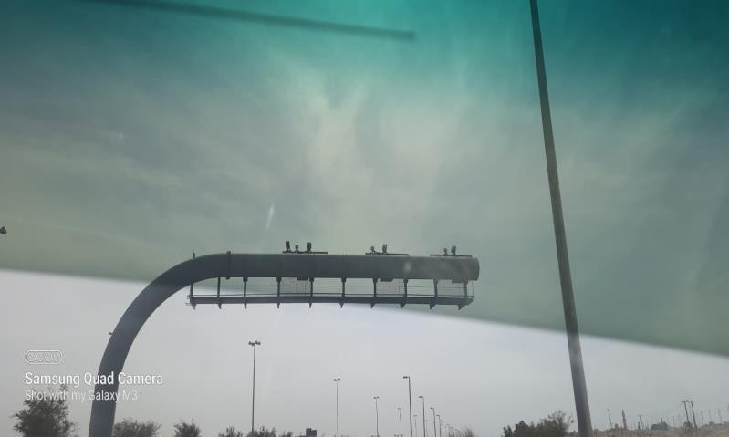
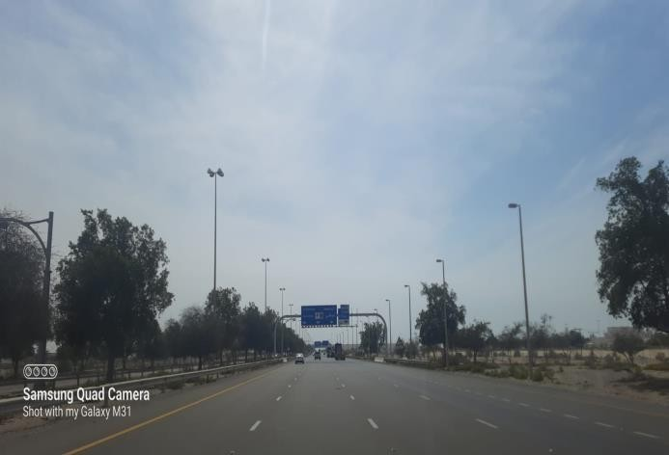
Sign Gantry Height 6.00m.
Sign Gantry Height 6.00m.
Sign Gantry Height 6.00m.
Sign Gantry Height 6.00m.
Sign Gantry Height 6.00m.
Take Exit 358 B to Abu Dhabi.
Gantry Height 6.00m.
Sign Gantry Height 6.15m.

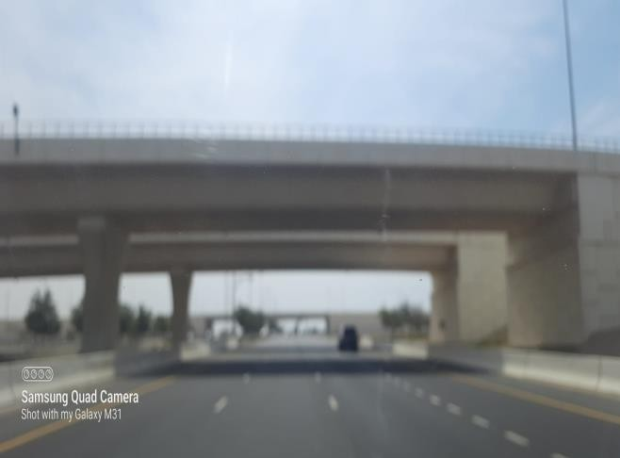
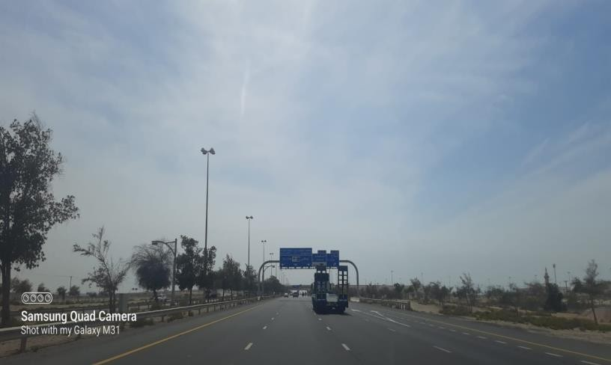

Sign Gantry Height 6.15m. Bridge Height 6.05m.
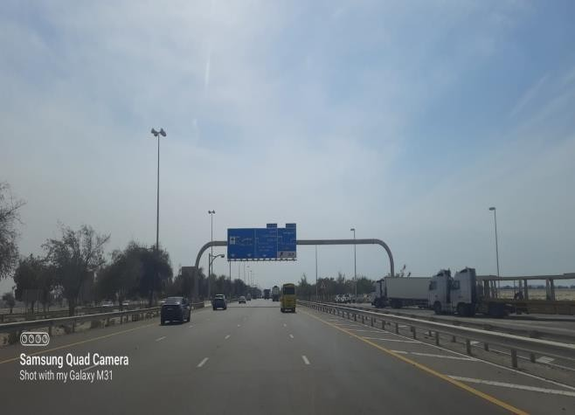
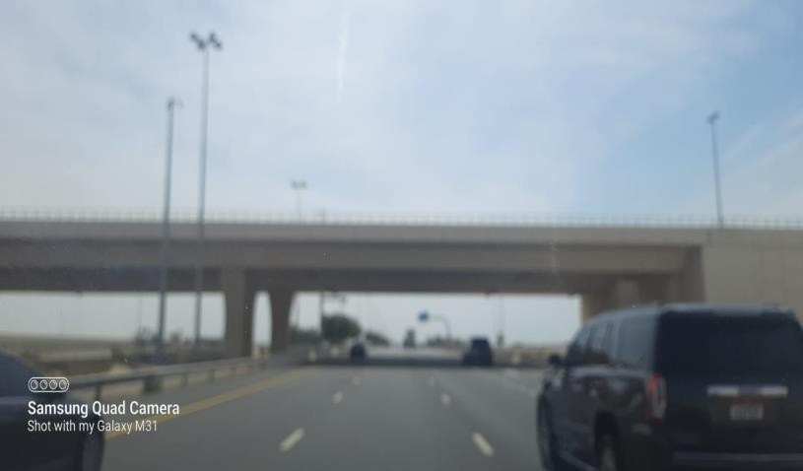

Bridge Height 6.05m. Sign Gantry Height 6.15m.
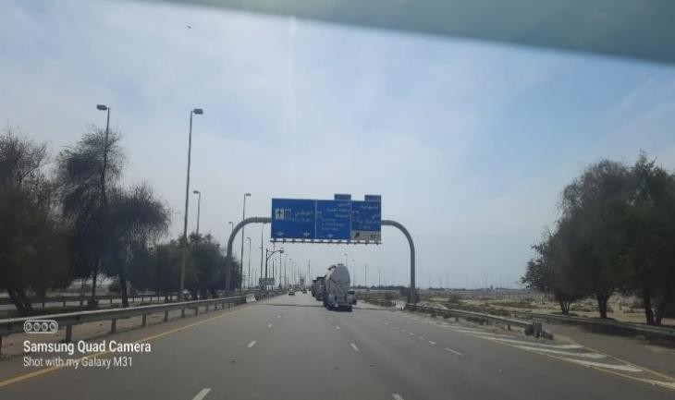
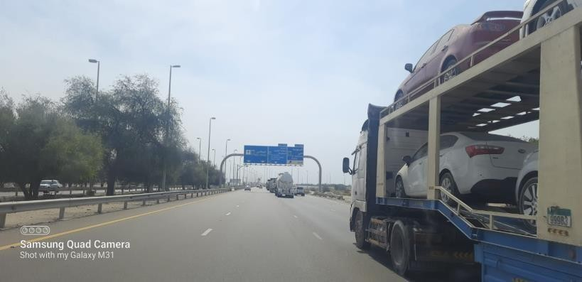

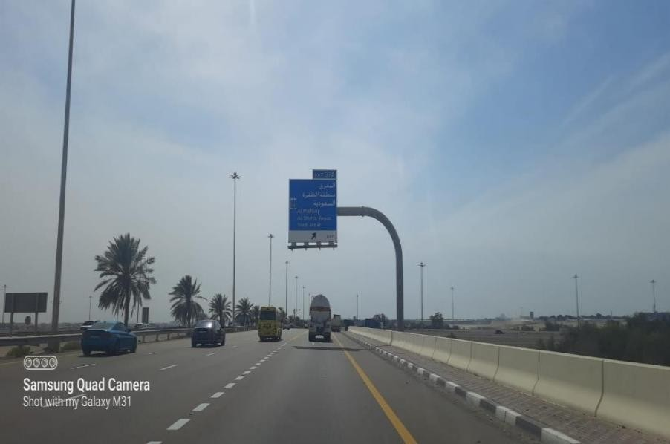
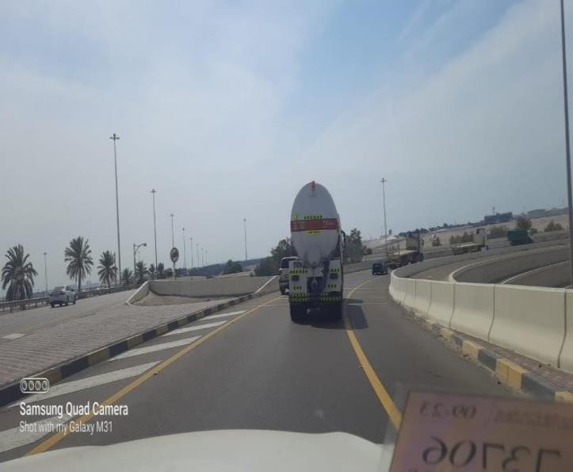
Sign Gantry Height 6.15m. Sign Gantry Height 6.15m.
Take Exit 37A.
Exit 37A.

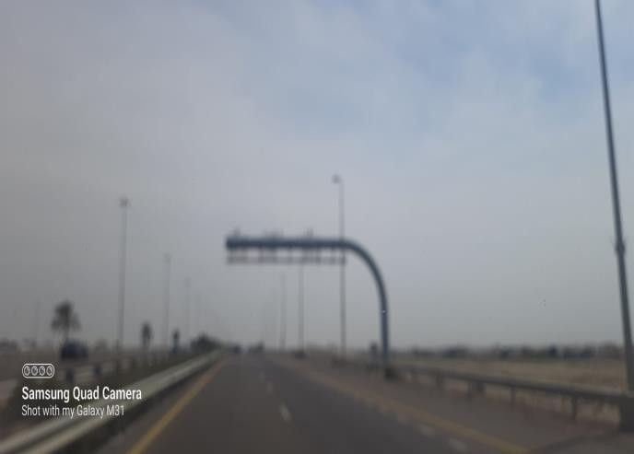
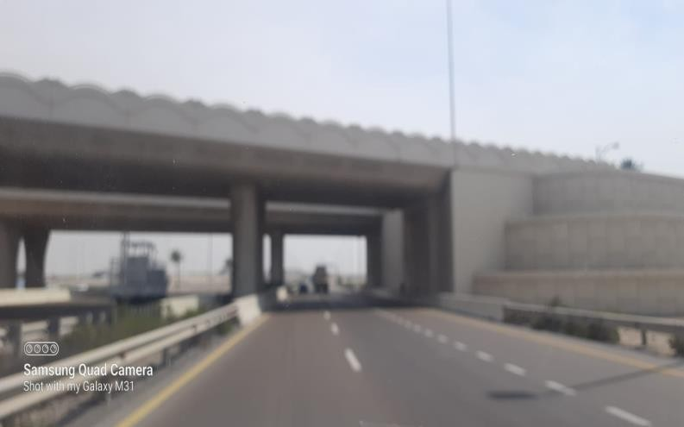
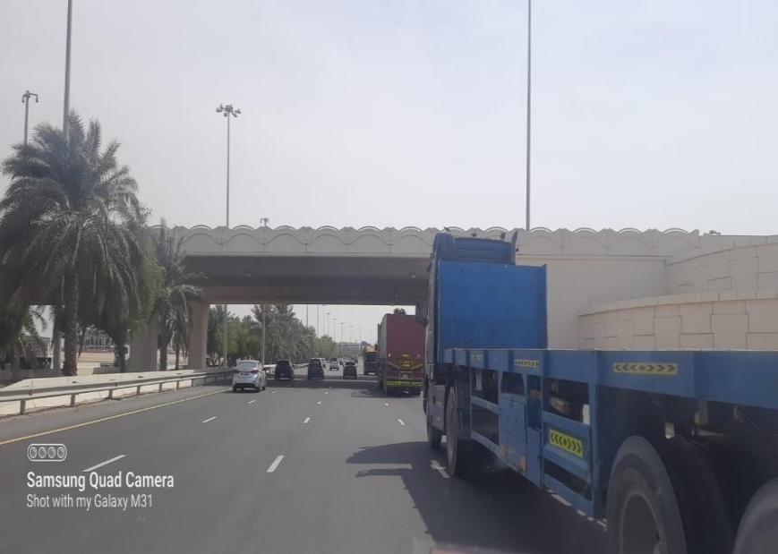
Sign Gantry Height 6.00m.
Sign Gantry Height 6.00m
Bridge Height 6.00m.

Bridge Height 6.05m.
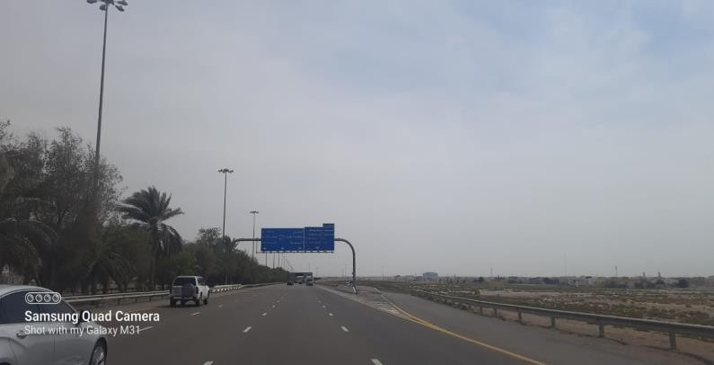

Sign Gantry 6.00m.
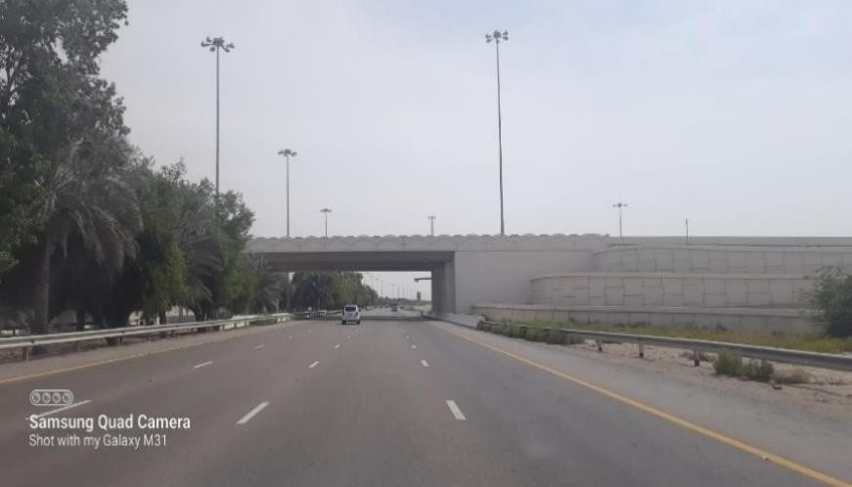
Gantry 6.00m.
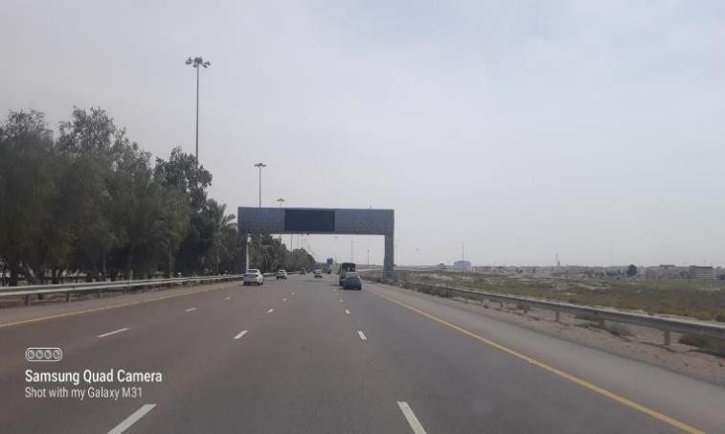

Information Screen Height 6.00m.

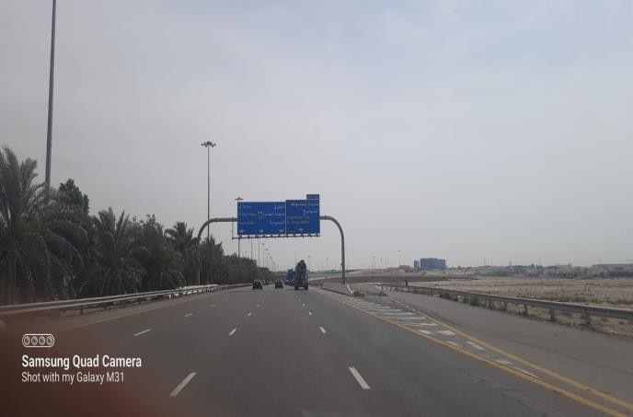

Bridge Height 6.00m.

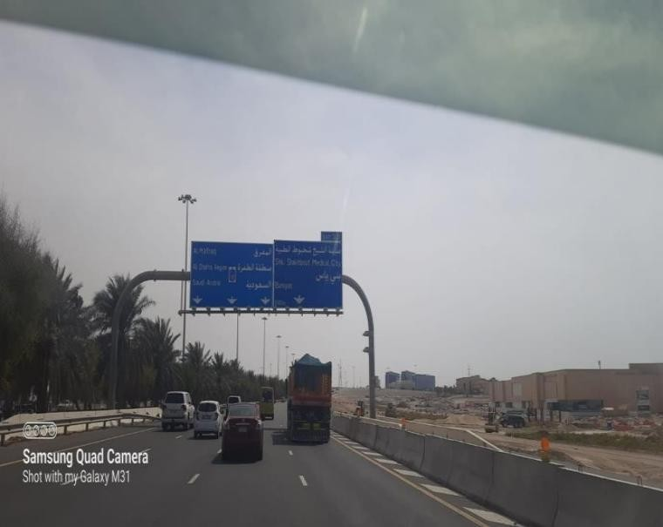

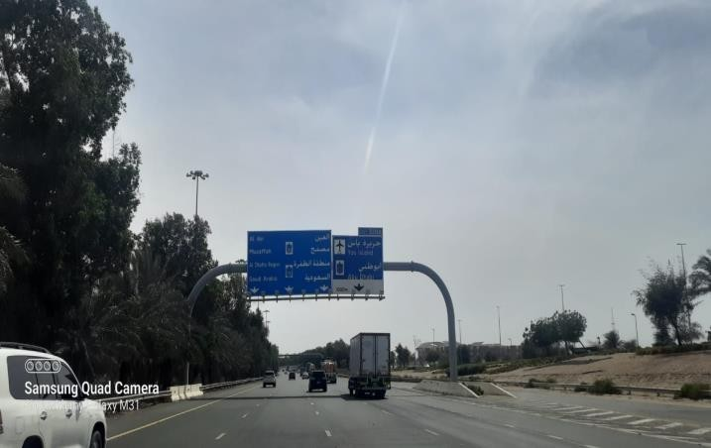
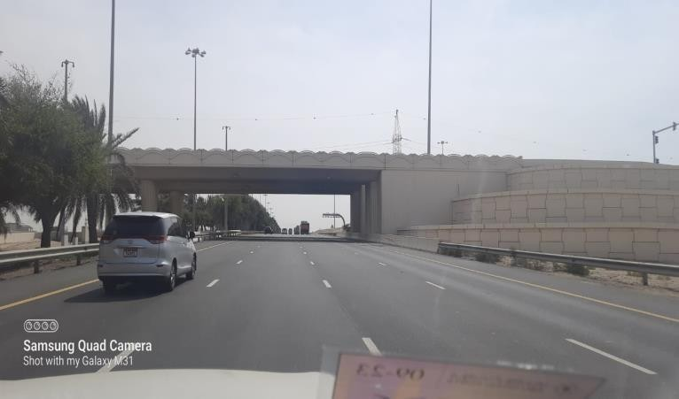
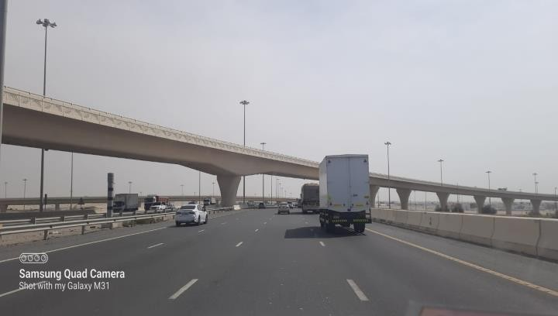
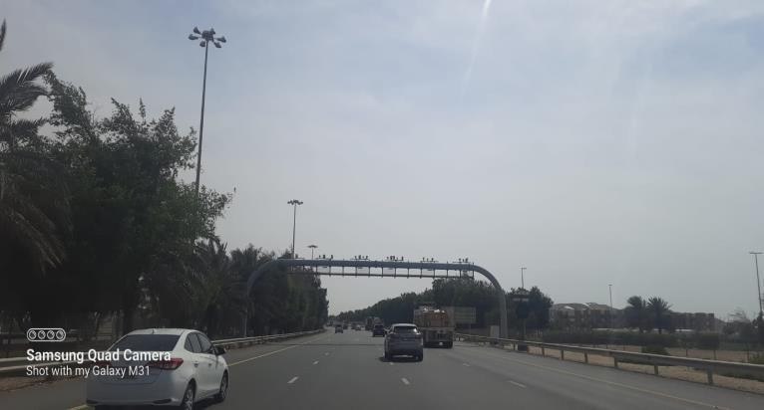
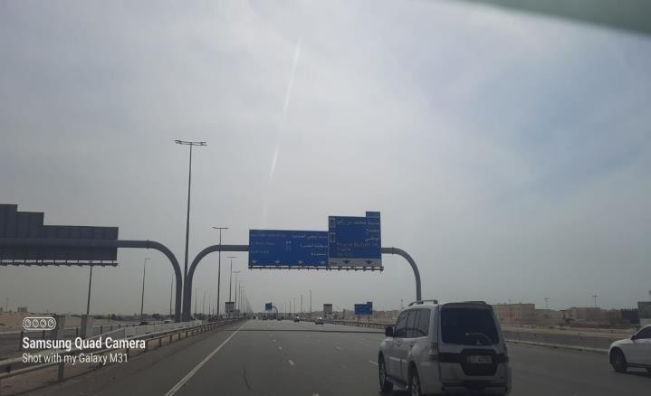
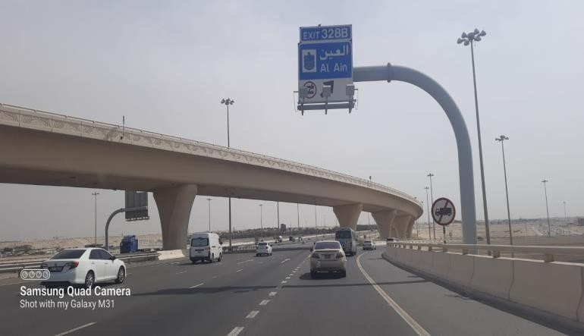
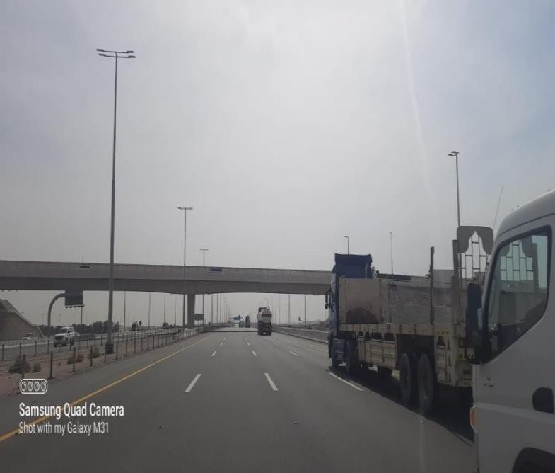
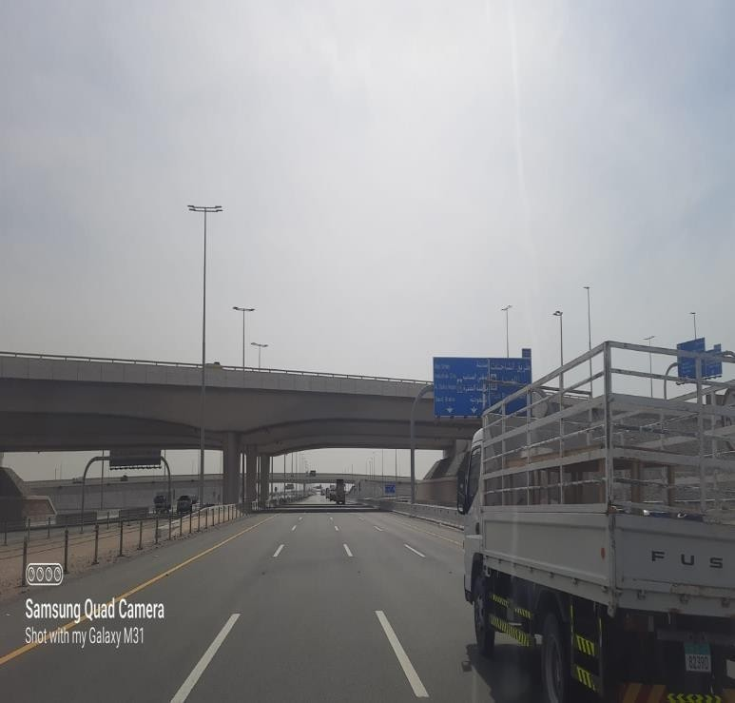
Mafraq Bridge Height 6.15m.

Bridge Height 6.00m. Sign Gantry Height 6.00m.

Camera Gantry Height 6.50m. Bridge Height 6.20m.

Bridge Height 6.50m. Sign Gantry Height 6.00m.

Musaffah Bridge Height 6.15m.

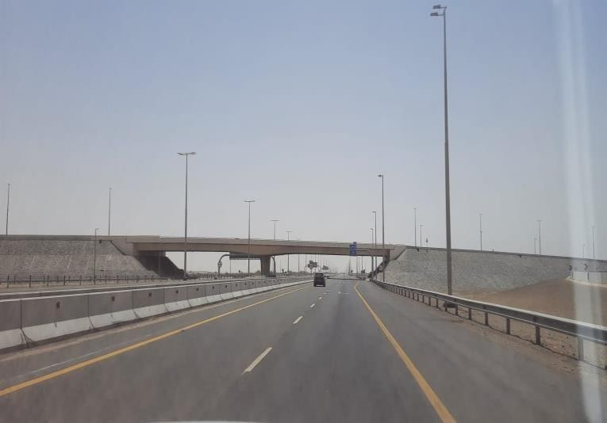
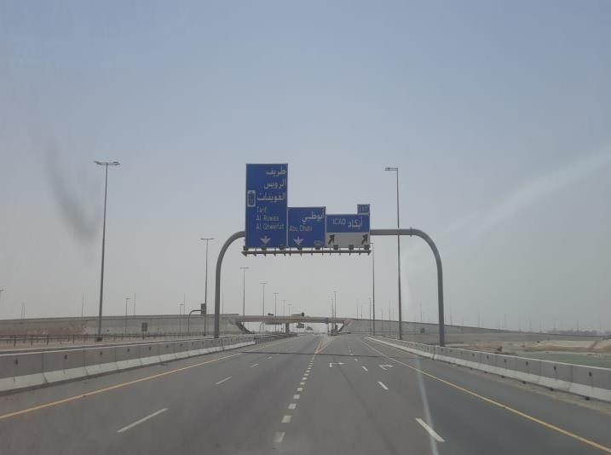

Sign Gantry Height 6.60m. I CAD II Bridge Height 6.70m.
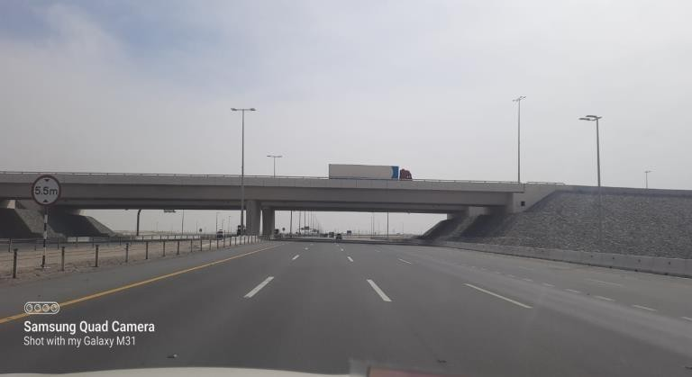
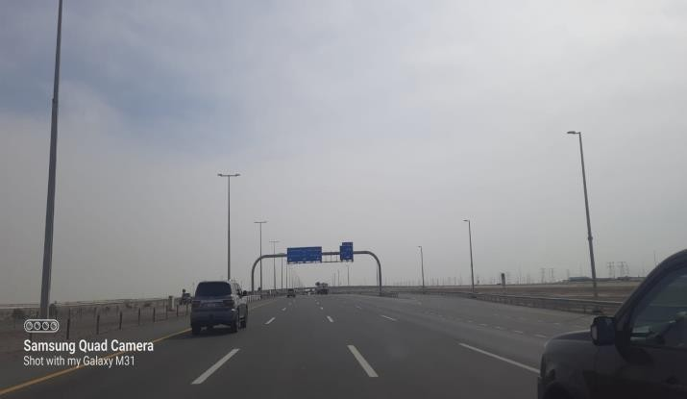

Sign Gantry Bypass Available. I CAD III Bridge Height 6.70m.
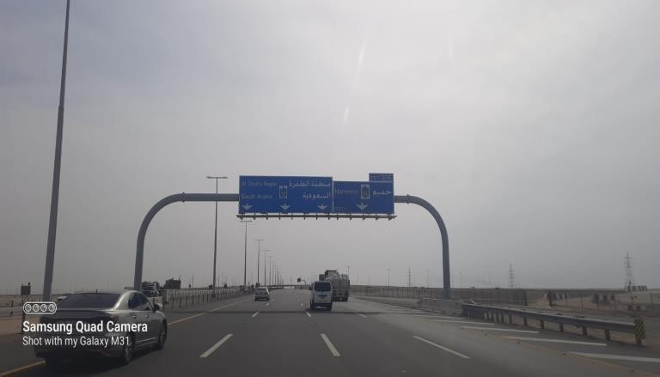
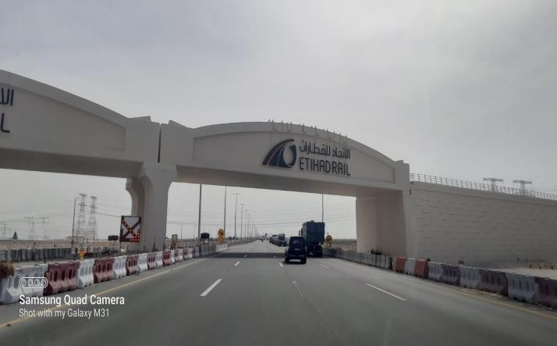

Etihad Rail Bridge Height 6.50m. Sign Gantry Height 6.70m.
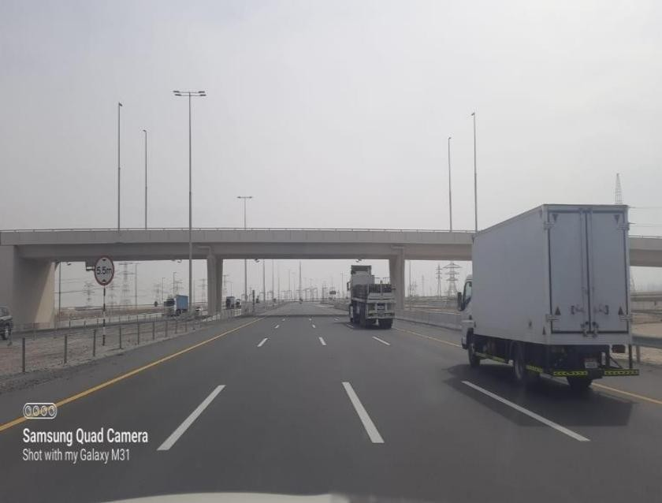
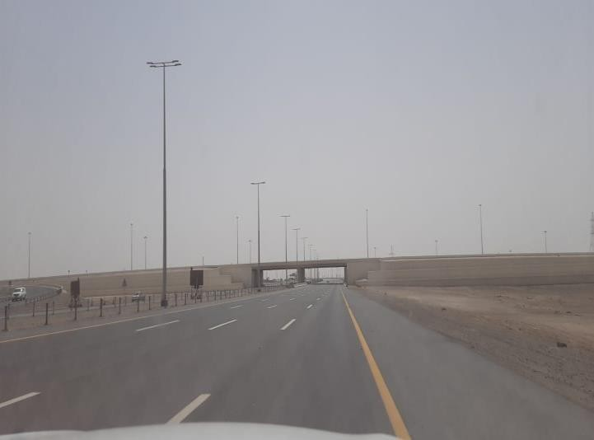

Hameem Bridge Height 6.70m. Bridge Height 6.70m.

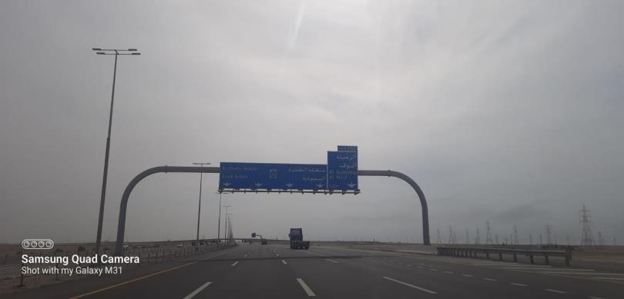
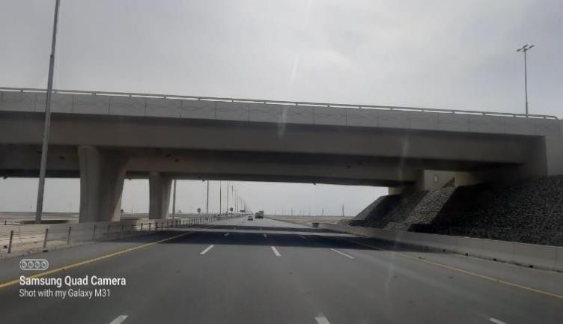
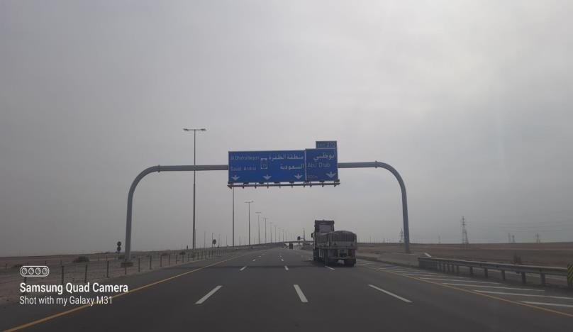
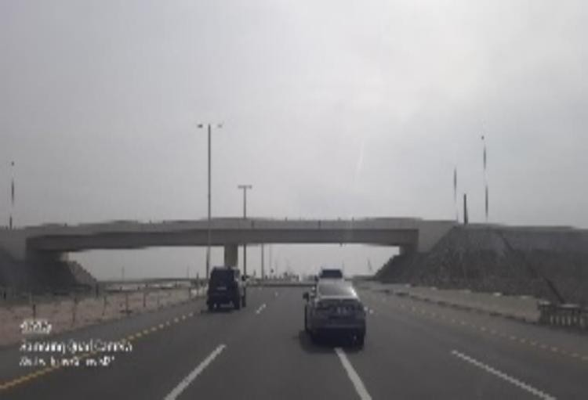
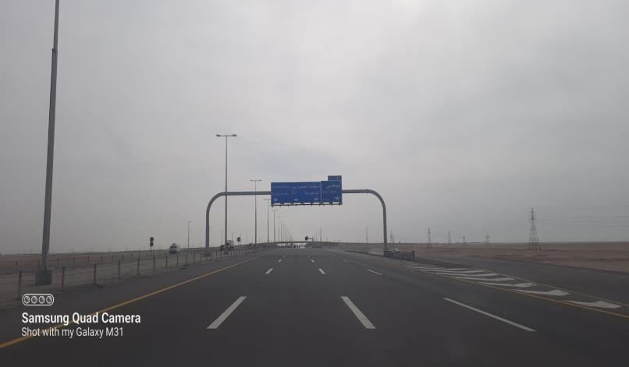
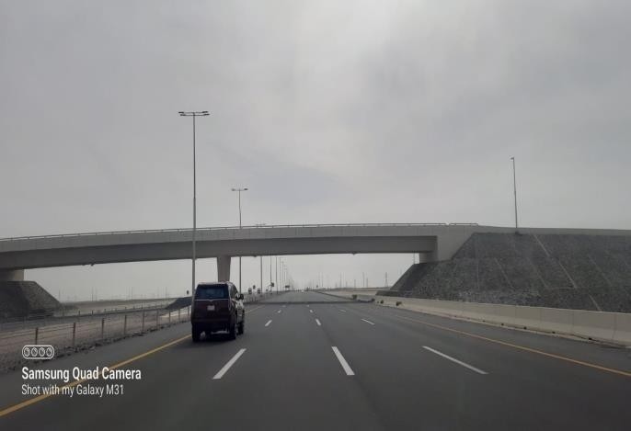
Sign Gantry Height 6.60m.

Sign Gantry Height 6.60m.

Bridge Height 6.70m.

Bridge Height 6.70m.

11 | P a g e

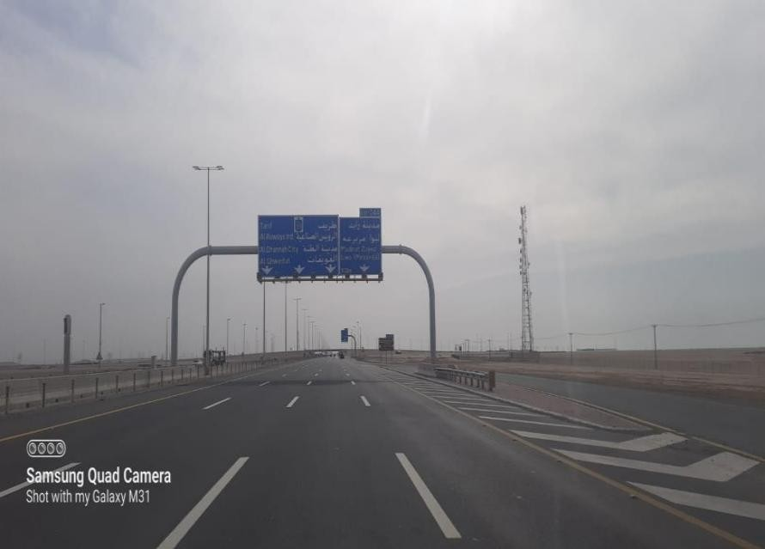
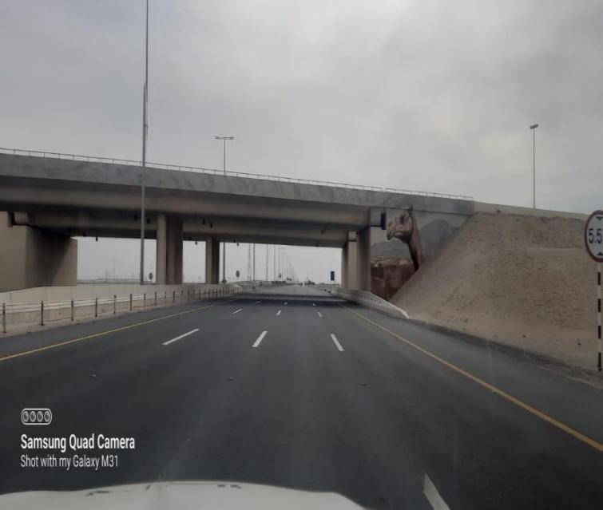
Sign Gantry Height 6.60m. Bridge Height 6.70m.
Sign Gantry Height 6.60m.
Bridge Height 6.70m.

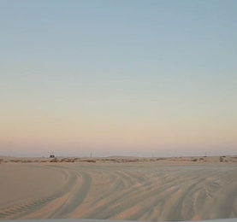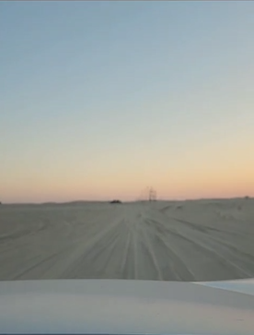
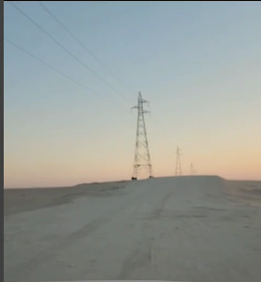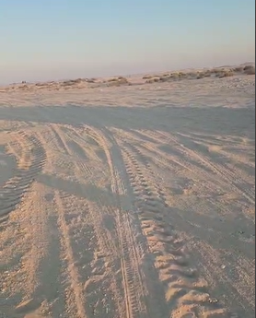
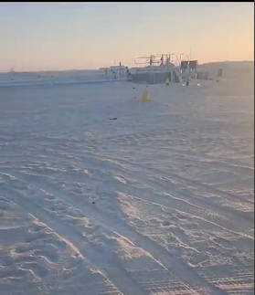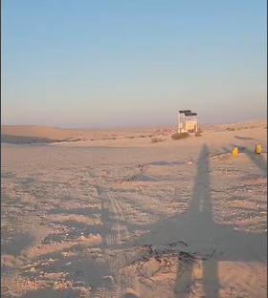

OFFLOAD SITE AD 234 RIG

